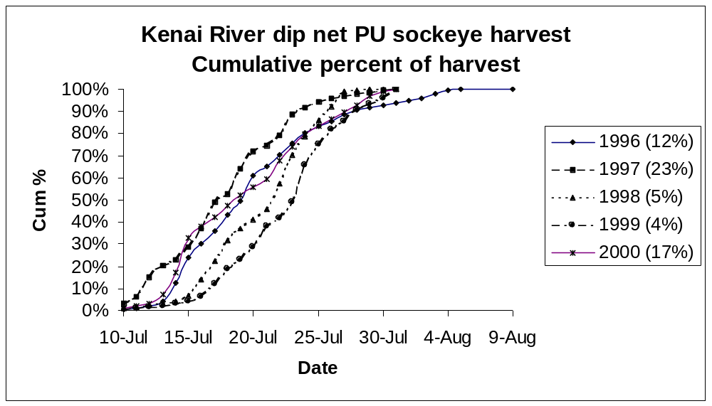

Average % sockeye salmon harvest from 10-14 July ~ 10% during 1996-2000. Average total harvest of sockeye salmon in the Kenai River dip net PU fishery during 1996-2001 ~ 120,000 fish. Therefore, average reduction in sockeye salmon harvest could be 120,000*10% = 12,000 fish. Percent harvest 10-14 July varied among years from low of 4% (1999) to 23% (1997) as a function of effort and likely affected by sockeye salmon run timing. Thus potential range in reduction of sockeye salmon harvest by starting Kenai PU fishery on 15 July on average is 120,000*4% ~ 4,800 fish to 120,000*25% ~ 30,000 fish.

